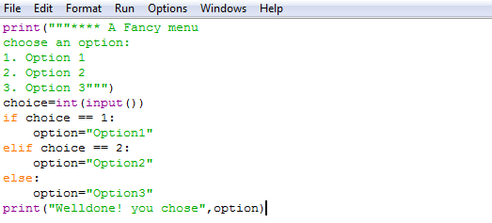Testing and correcting errors:

**Example code:**

In order to test sections of code we create a test plan. This is usually presented in a table.

|  |  |  |  |
| --- | --- | --- | --- |
| Menu choices | | | |
| Data | Expected output | Actual | |
| Integers 1,2,3 | Prints the correct option | Prints the correct option | |
| Strings “one” | | Error message | Error message |
| Floats 3.0 | | Error message | Error message |

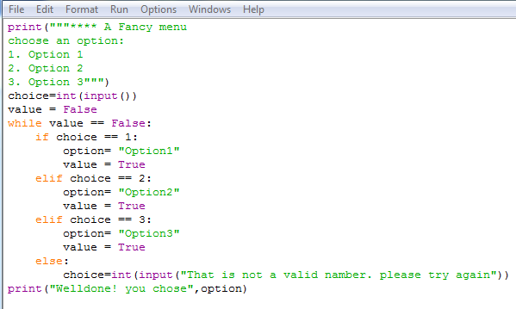**Error 2:**

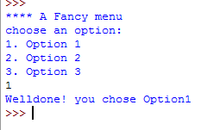

Error 2 code is as improvement from error 1 as it has a while loop that allows the user to input there option again if it is not a integer.

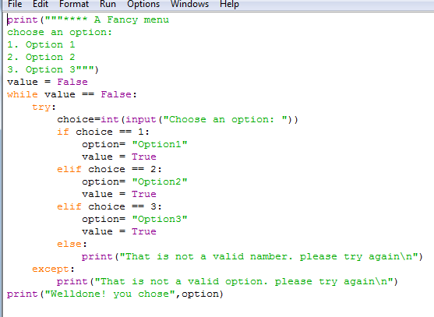**Error 3:**

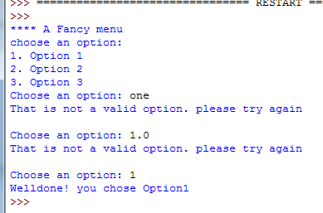error 3 code as well as having a while loop it also has a “try” and “except” statement. This means that it does not matter what the user inputs if it is not an option, they will be able to try again.